Task No & Title: | BSBCMN201A    Work effectively in a business environment
Title: | Basic Microsoft Word
Suitable for Classes: | Certificate II Business
Area: | Technology & Enterprise
Teacher: | Mr Peter Faulks

Timeline

Date Due:

Task Brief:

Files Required

Items highlighted in yellow are tasks for you to complete
1
Items in Purple are help tips

Unit | Number | Title | Study Time
1 | BSBCMN201A | Work effectively in a business environment | 20
2 | BSBCMN202A | Organize and complete daily work activities | 15
3 | BSBCMN203A | Communicate in the workplace | 30
4 | BSBCMN204A | Work effectively with others | 20
5 | BSBCMN205A | Use business technology | 30
6 | BSBCMN211A | Participate in workplace safety procedures | 15
7 | BSBCMN213A | Produce simple word processed documents | 40
8 | BSBCMN214A | Create and use simple spreadsheets | 20
9 | BSBCMN108A | Develop keyboard skills | 40
10 | BSBCMN107A | Operate a Personal Computer | 20
11 | ICAITU013C | Integrate Commercial computer packages | 30
12 | ICAITU012C | Design Organizational Documents using computer | 50
 |  | TOTAL

Basic Microsoft Word

This – worksheet will take you through the basics of Microsoft Word ,there are several versions so some screens will look different to the ones shown here.

Formatting text

Using the Format Toolbar
One way to format the content of a cell is to use the format toolbar. Font and cell attributes can be added from shortcut buttons on the formatting bar. If this toolbar is not already visible on the screen, select View Menu|Toolbars|Formatting from the menu bar.
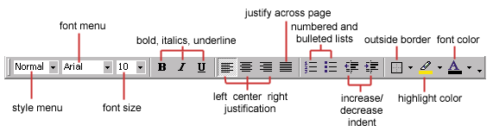

Using the Format Dialog box
For a complete list of formatting options, right-click on the highlighted cells and choose Format Cells from the shortcut menu or select Format|Cells from the menu bar.
The following dialogue boxes show the different features you can set.
1 Number — The data type can be selected from the options on this tab. Select General if the cell contains text and number, or another numerical category if the cell is a number that will be included in functions or formulas.
The Format Cells dialogue box is shown below with the Number tab selected:
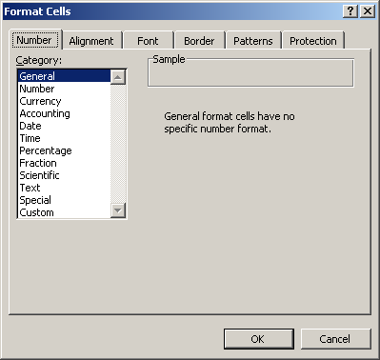

2 Alignment — These options allow you to change the position and alignment of text or the data within the cell.
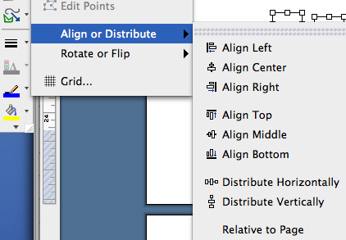

This is different from Aligning objects (Drawing Toolbar) (Align these object bottom and distributed horizontally)

The Format Cells dialog box is shown below with the Alignment tab selected:
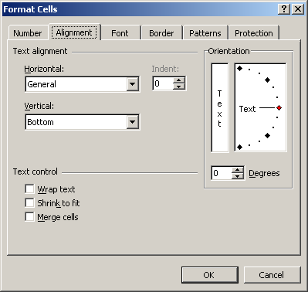

3 Font —All font attributes are displayed in this tab including font face, size, style, and effects.
Shown below is the Format Cells dialog box with the Font tab selected:
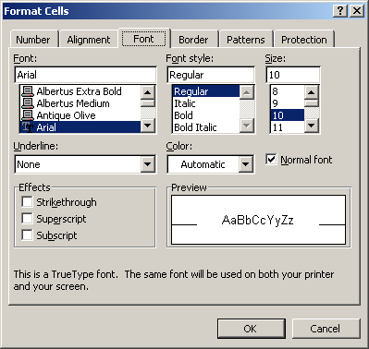

A sample is show of the font
This is Arial font
Create examples as follows highlight each sentence and change accordingly

Arial Bold
Arial Italic
Arial 16pt
Arial Strikethrough 20pt
Arial H20 with the 2 subscript
Arial 20th June with the th supercsript
Arial in a colour Bold Italic large size

Change the font to something fancy and recreate the examples

4 Border and Pattern —These tabs allow you to add borders, shading, and background colours to a cell.
Shown below is the Format Cells dialogue box with the Border tab selected:
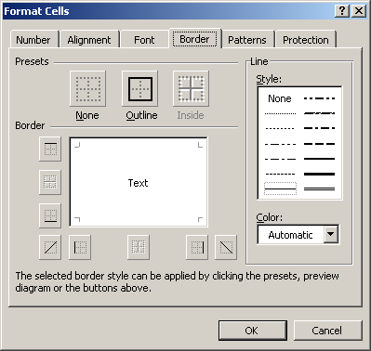
Insert a several text boxes and create at least 6 diferent borders, paterns or or shading including

Outside border lines
Inside pattern
Inside gradient
Box shaded outside lines on three sides only
A Creative text box

Shown below is the Format Cells box with the Patterns tab selected:
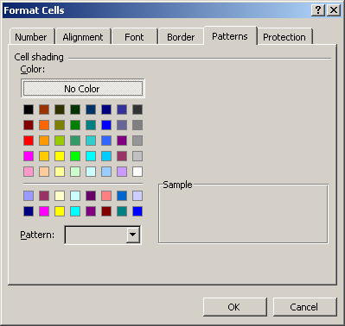

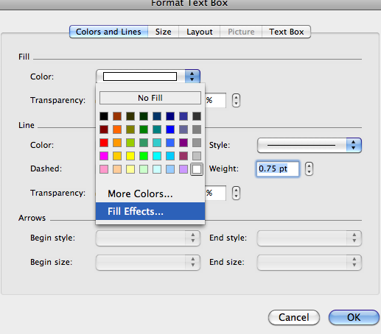

Start the Word Program

Assuming that you have the PC turned on with Windows or Mac running:

- Click on the Explorer (PC) or Hard Drive (Mac) button

- Point to Microsoft Word in Explorer double click (Microsoft Word)

- Or on Start Menu - Programs - Click on Microsoft Word

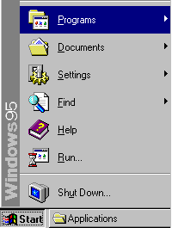
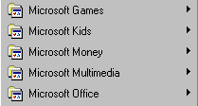
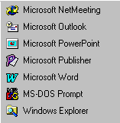
Or in Applications - Click on Microsoft Word
Programs

The Word Program will be displayed in a window as shown on the following page. (Image may vary depending on which version of Office you are using)

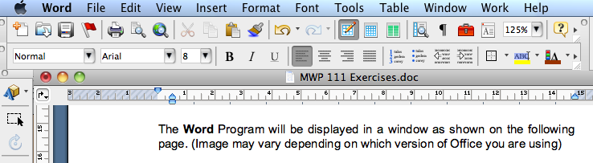

- Click on the Maximise button to fill the screen if the Microsoft Word window is not fully open. (Green button on a Mac)

The screen will appear very busy. Do not be concerned with all the buttons etc., you will learn to use most of these as you work through this manual.

Maximise button

The Insertion Point will be flashing on the screen
Start
Word
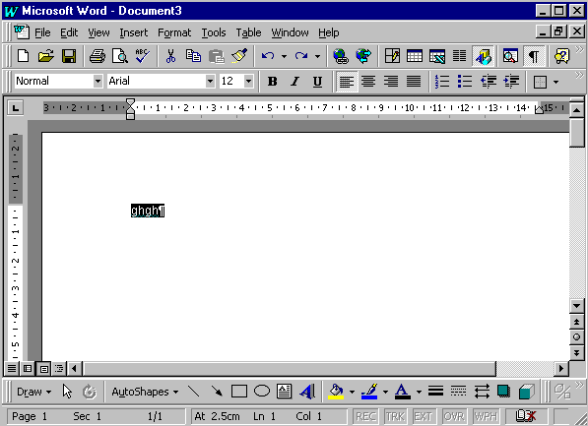
This is the Work Area where you type the text for your file. The text will go wherever the insertion point is.

We will look at the components that make up the screen on the following page.

The Word Workplace

Try not to feel overwhelmed by the vast array of options available. You will soon be familiar with most of the basic features. As your skills advance you will find you are using many of the features without thinking twice.

We will start from the top of the Word screen and work down.

The Title Bar
Minimise

Maximise
Close
File Name
The Title Bar displays the name of the file currently on the screen. A default name eg. Document 1, will be used until you have saved and named the file. The Title Bar also contains the Minimise and Maximise buttons and the Close button for the program.

Mac Maximize

The Menu Bar

This bar holds all the functions grouped together into menus. Anything you want to do with your text can be carried out through these menus.

- Click on File in the Menu Bar - read through the options available - do not click on any of the options yet.

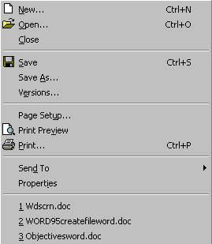The common options on these menus also have buttons on the toolbar as an easy way to activate them.

- Move the mouse to the next menu Edit - notice that the File menu closes as the Edit menu opens

- Move to each menu and just look at the options available - do not click on any of the options yet.

NOTE: Clicking on the menu heading again, or clicking into the work area of the screen will close a menu.

The Standard Toolbar

This toolbar holds buttons that act as shortcuts to some of the options available in the menu bar. Most of these buttons will be covered in this manual.

The most commonly used functions are held here, such as Open or Save a file.

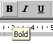
- Move the mouse slowly over each button as shown below. A tool tip (pale yellow box) will appear to indicate the button’s function - do not click on the button yet - just look at the tip.
Tool Tip

The Formatting Toolbar
This toolbar also holds buttons for commonly used functions. The buttons on this toolbar are for changing the way the document text looks.

The Work Area & Scroll Bars

The work area is where the text for the document is typed. Scroll bars are available to move horizontally and vertically through a document.

Vertical Scroll Bar

The Work Area
Horizontal Scroll Bar

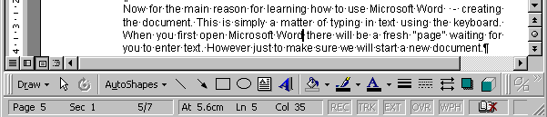

Layout buttons
Page Layout View
Normal View
Outline View

On-line Layout View

The layout buttons give us slightly different views of the page. Don’t press any of these buttons now. If you have and find you’re stuck then click on
View ➢ Page Layout or Normal in the Menu bar to return to a page view.

The Drawing Toolbar

The Drawing Toolbar contains tools for drawing and colouring shapes and lines.

Status bar
Page 5 of 7 pages

The Status bar indicates our position within a document – sometimes displays a message to assist us.

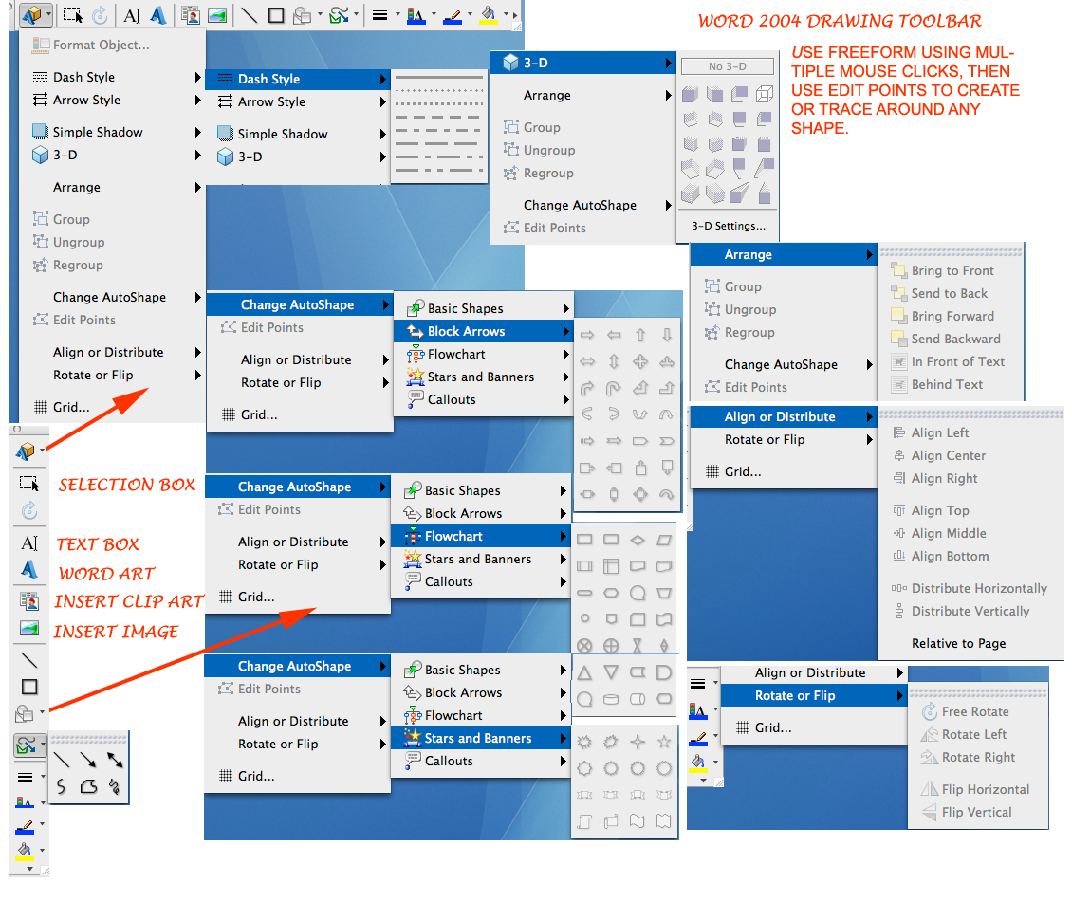

Creating a Document

Now for the main reason for learning how to use Microsoft Word - creating the document. This is simply a matter of typing in text using the keyboard. When you first open Microsoft Word there will be a fresh “page” waiting for you to enter text. However just to make sure we will start a new document.

- Click on the New button in the toolbar

New

The Insertion Point or Cursor is a flashing line to the top left of the screen. Text will be entered here as you type.
This is the Work Area where you type the text for your file. The text will go wherever the insertion point is.
The Insertion Point will be flashing on the screen

Microsoft Word MWP 111 Exercises

MWP 111 EXERSIZE 1
- The following short document – has lots of mistakes - you will fix them by clicking Tools – Spelling (Do it now)

- Ignore the red squiggly lines that will appear under the incorrect words - these indicate incorrect spelling.

Using Microsoft Word is eeasy when you know how. The workplace can loool veery confunsing at first but you vill qvickly learn to navigate your way awound.

Remember that you do not need to pwess the Enter key at the end of each line because the wordwrap takes care of that for you.

Use the enter key to start a new paragraph or to create blank lines!

MWP 111 Exersize 2

First we must determine which folder the file will be saved in. If you do not want to save files to your own drive ask for a Floppy Disk and use the A: Drive

- Create a folder called Training on your own shared student folder in the Year of study (i.e. studying year 11 put this folder in there).
- Create a new folder called Cert2

We are going to save the file you type above in the Cert2 folder to your shared folder you just used - (Student Shared folder) or on the A: drive

Alternative
- We used to use the floppy disk in A drive (ask the teacher for a disk if you don’t yet have one) or use your Thumb Drive or Hard Drive (USB)

- Type MSWord1 – to make it the File name
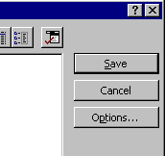

Save A File

- Click on SAVE to save the file

The Save As dialogue box will close and return you to the Word workplace.

The File name will appear at the top of the screen.

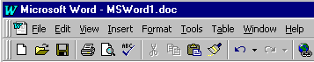
NOTE: You may or may not have the .doc extension make sure you include the extension .doc

USING SAVE AS

Click on File and Save As

- Save the file as new name MSWord2 in the File name box and click on Save

Now the file MSWord2 will be displayed in the Title bar and the file MSWord1 will be closed.

MWP 111 Exersize 3

Practice Exercise:

- Click on the New File button

- Type this text

- You could be one of our lucky readers to receive the latest in bakehouse technology from Golden Goods. The newly designed Golden Goodness Baker is unique in its design.

- Save this file as Golden Goods on the A: drive or to your shared folder in the Cert2 folder

- Close the file when you have finished

Practice Exercise

In this exercise you will create a new file but save it in the Cert2 folder.

- Create a New file
- Type the following text make this a better looking font and size

When you drive on Rockpath, you’re driving on some of the best tyres available. Call into a participating centre and fit two tyres for the price of one. Fitting and balancing included.

- Save this file as Rockpath on the A: drive or to your shared folder in the Cert2 folder (if you need help start at Step 1 or ask the teacher)
- Close the file when you have finished

Practice Exercise

You are responsible for advertising for the courier business you work for.

- Create a New file
- Type the following text make this a better looking font and size

ON THE MOVE

As an experienced courier company, with both national and international clients, we can offer your company the opportunity for fast, reliable and affordable freight.

Some of the qualities that our company offers are:

A large fleet of speedy trucks
24 Hour phone service
Competitive rates

Call our number and talk to our cheerful staff about what we can offer your business!!

Call 1234 On the move

- Save this file as Advertising on the A: drive or to your shared folder in the Cert2 folder
- Close the file when you have finished

Well Done now move on to MWP 112 and more exercises


Student Name: | Date submitted:
I declare this evidence to have been produced by me the undersigned.

Candidate’s signature:
Title of Portfolio evidence presented (include Unit No and section i.e. 03.05)
:-
□ Outcomes from learning programs (including self-learning and online learning)
□ Assessment feedback (from a trainer or assessor)
□ Observation checklists (from a workplace supervisor or assessor)
□ Written statements or references (including workplace supervisors, community leaders)
□ Job descriptions
□ Work journal
□ Work samples
□ Finished products
□ Product descriptions or specifications (supporting the product samples included)
□ Statutory declarations
□ List others (or delete any from above not provided)
- All work submitted to be word processed and spell checked.
- There must be at least two samples of evidence for each
Element within the Unit of Competency. This is sample 1 / 2
- All work submitted must be of a high quality and meet the
requirements of the Unit of Competency.
Other evidence (List each piece):
Assessor to complete
Evidence is Valid Sufficient Authentic Current
□ □ □ □

Assessor signature: _________________________________Date: _____________
Peter Faulks, BA Soc Sci, Grad Dip Ed, Cert IV AWT
Certificate II in Business assessor/teacher
Assessor to complete

Student is declared Competent Not Yet Competent
□ □

Keep a copy of this report with your file for evidence

